

**COMSATS University Islamabad, Lahore Campus**

**Task: Import/Export from CSV File in Neo4j using Cypher**

**Name:** Asad Haroon

**Registration Number:** SP17-BCS-012

**Section:** C

**Submitted To:** Ms. Kanza Hamid

**Topic:** Import/Export CSV

**Date: Thursday, 30 April 2020**

**Neo4J Task-(Import/Export CSV)**

1. Graph ScreenShot:

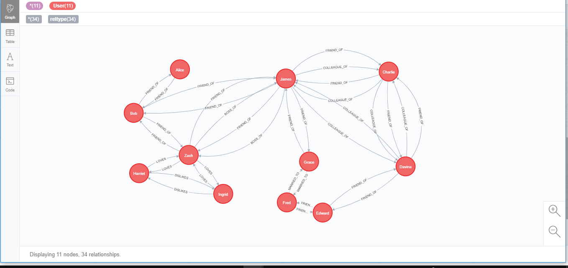

1. For Exporting and Importing Database/Whole Graph:
2. First step is to make settings in neo4j Project from where you want to Export Graph:

Add these lines (commands at end of File).

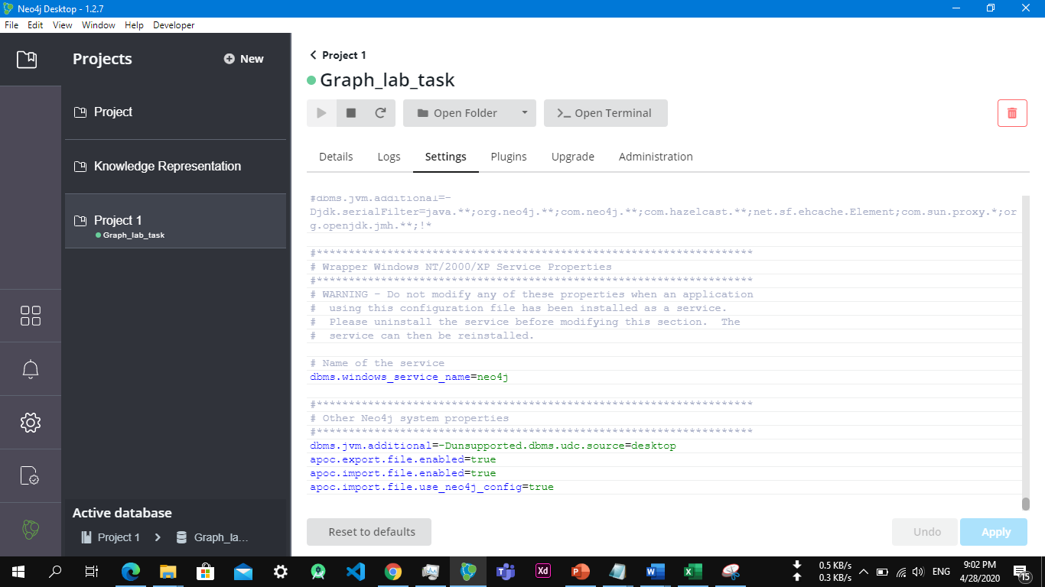

1. Second Step is to Add Plugin APOC. And Enable it in your Project.

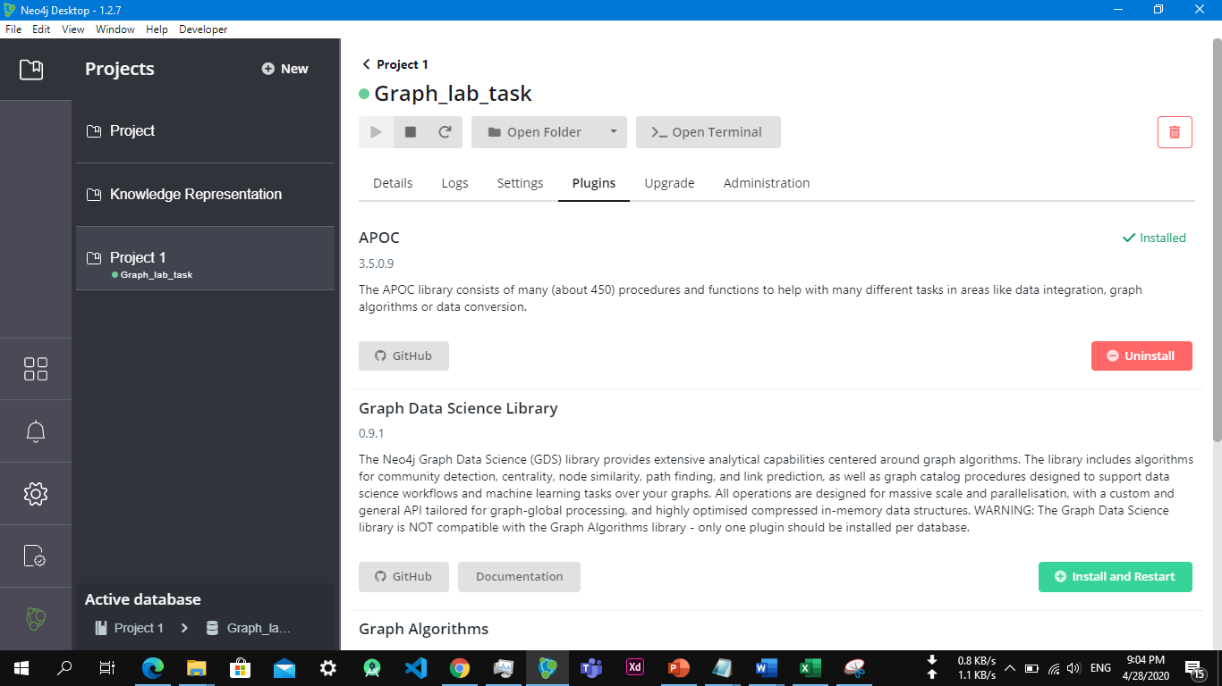

1. Third step is to Apply Export Cypher Query to export the graph:

For Relations Storage:

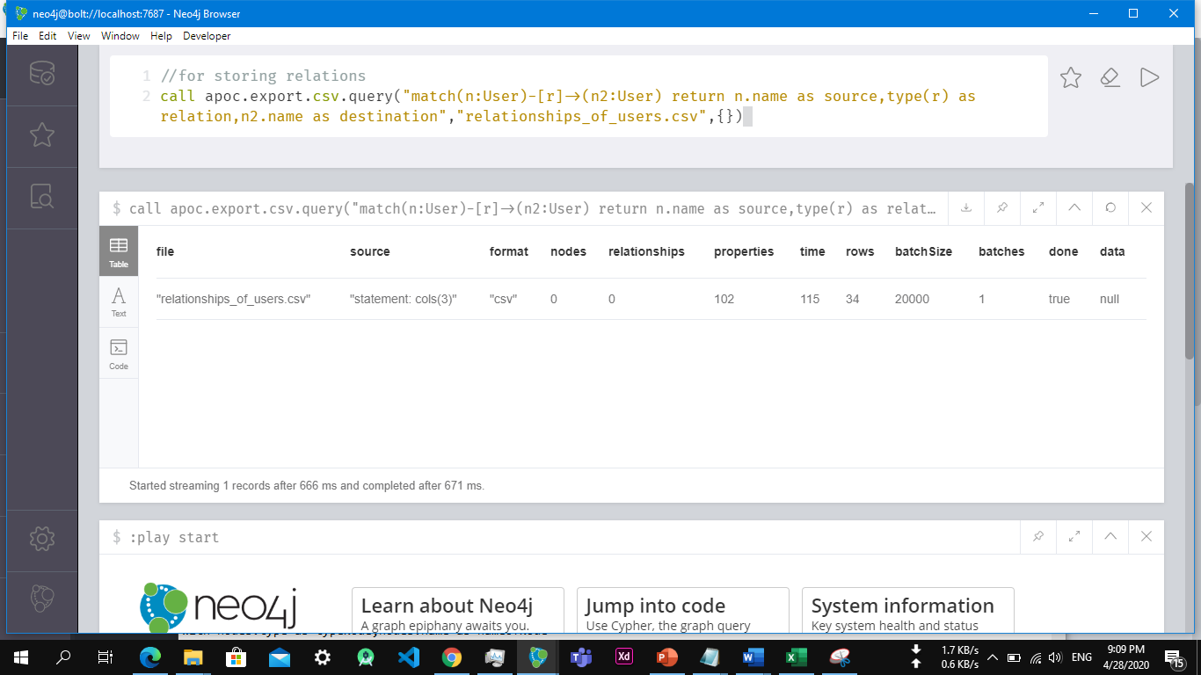

For Nodes Storage:

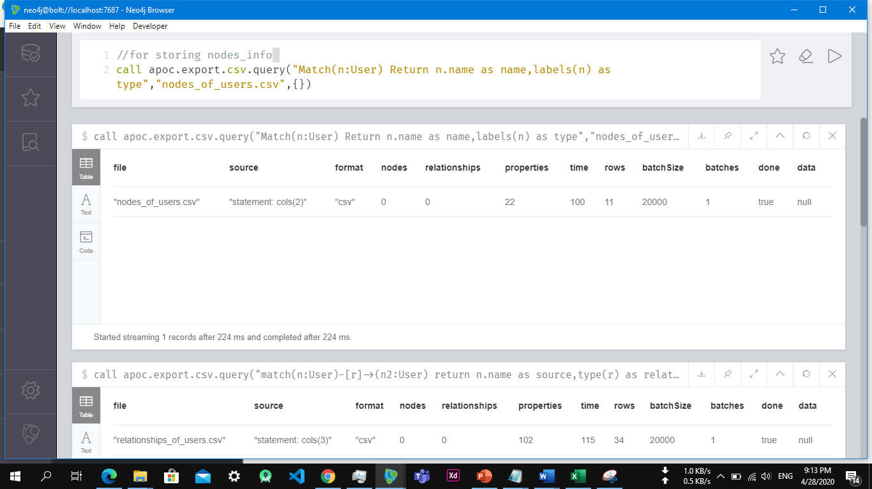

1. Now Our Files has been exported:

You can view Directory by Clicking Import Button:

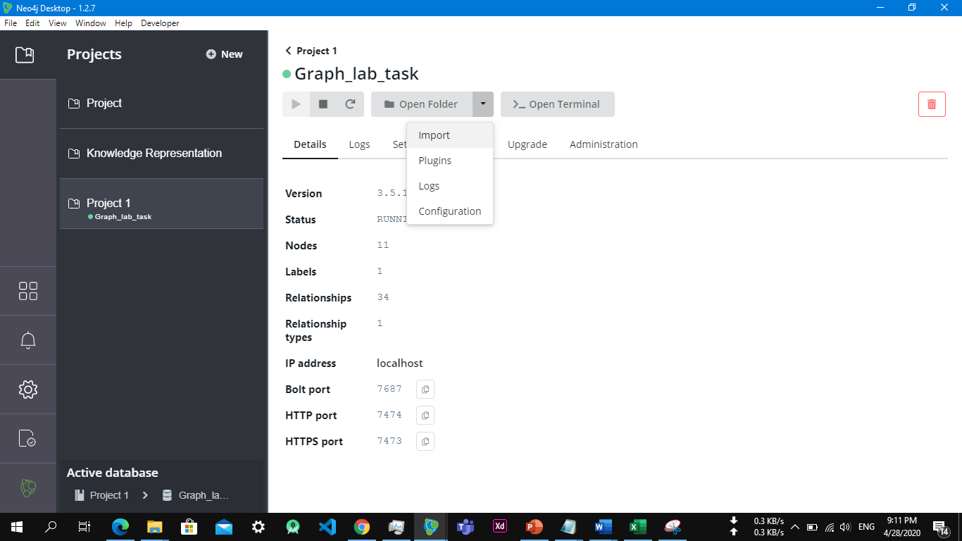

1. For Importing the Nodes and relationships, Create an Empty Project and then apply Import Queries here.
2. For Importing Nodes:

Repeat Same steps of adding Commands in Setting of Project, and enable APOC plugin in the new project.

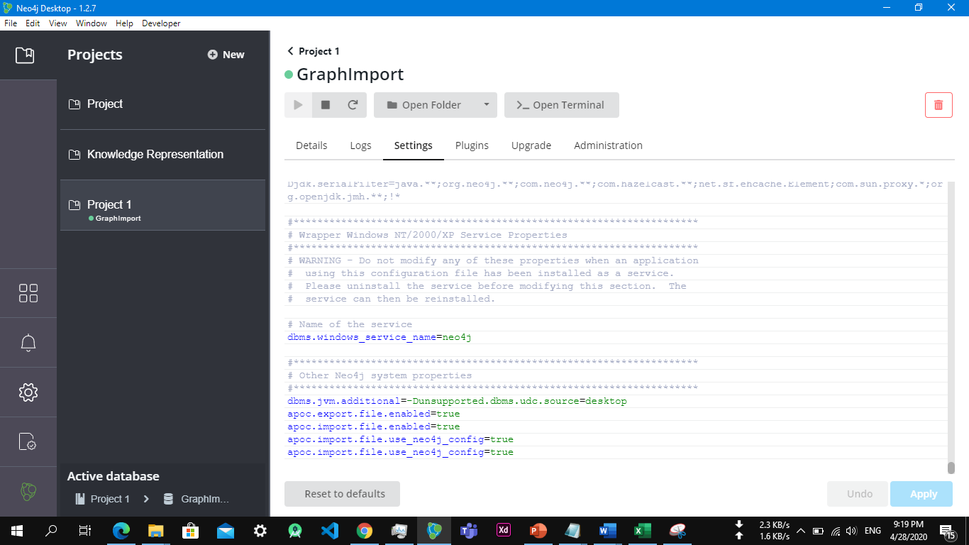

1. Now We have to Import Nodes first from CSV file:

By this Query as you can see our nodes have been created.

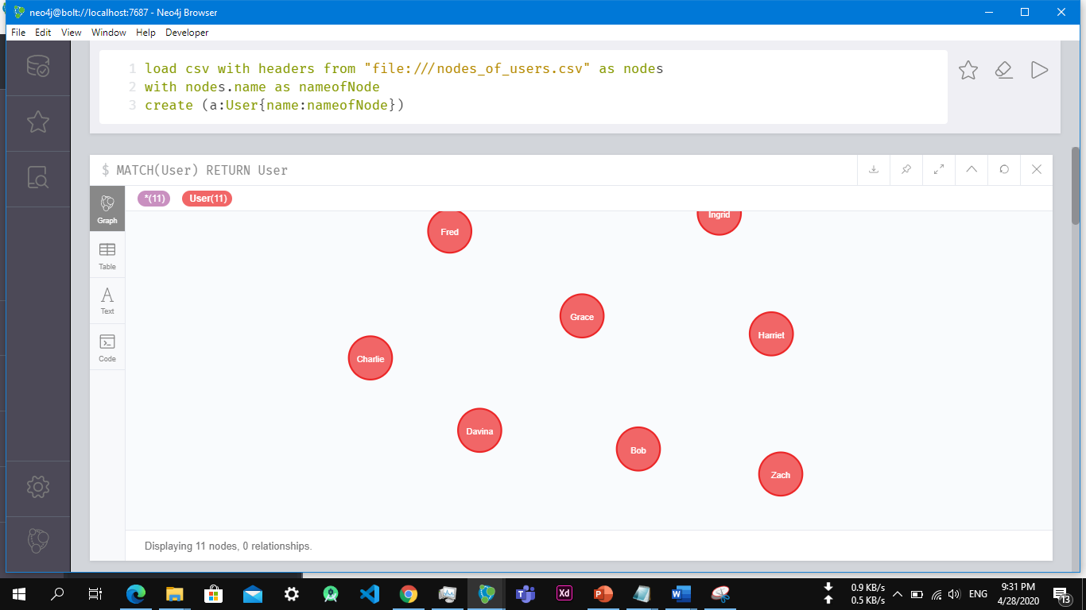

1. For Importing Relationships:

